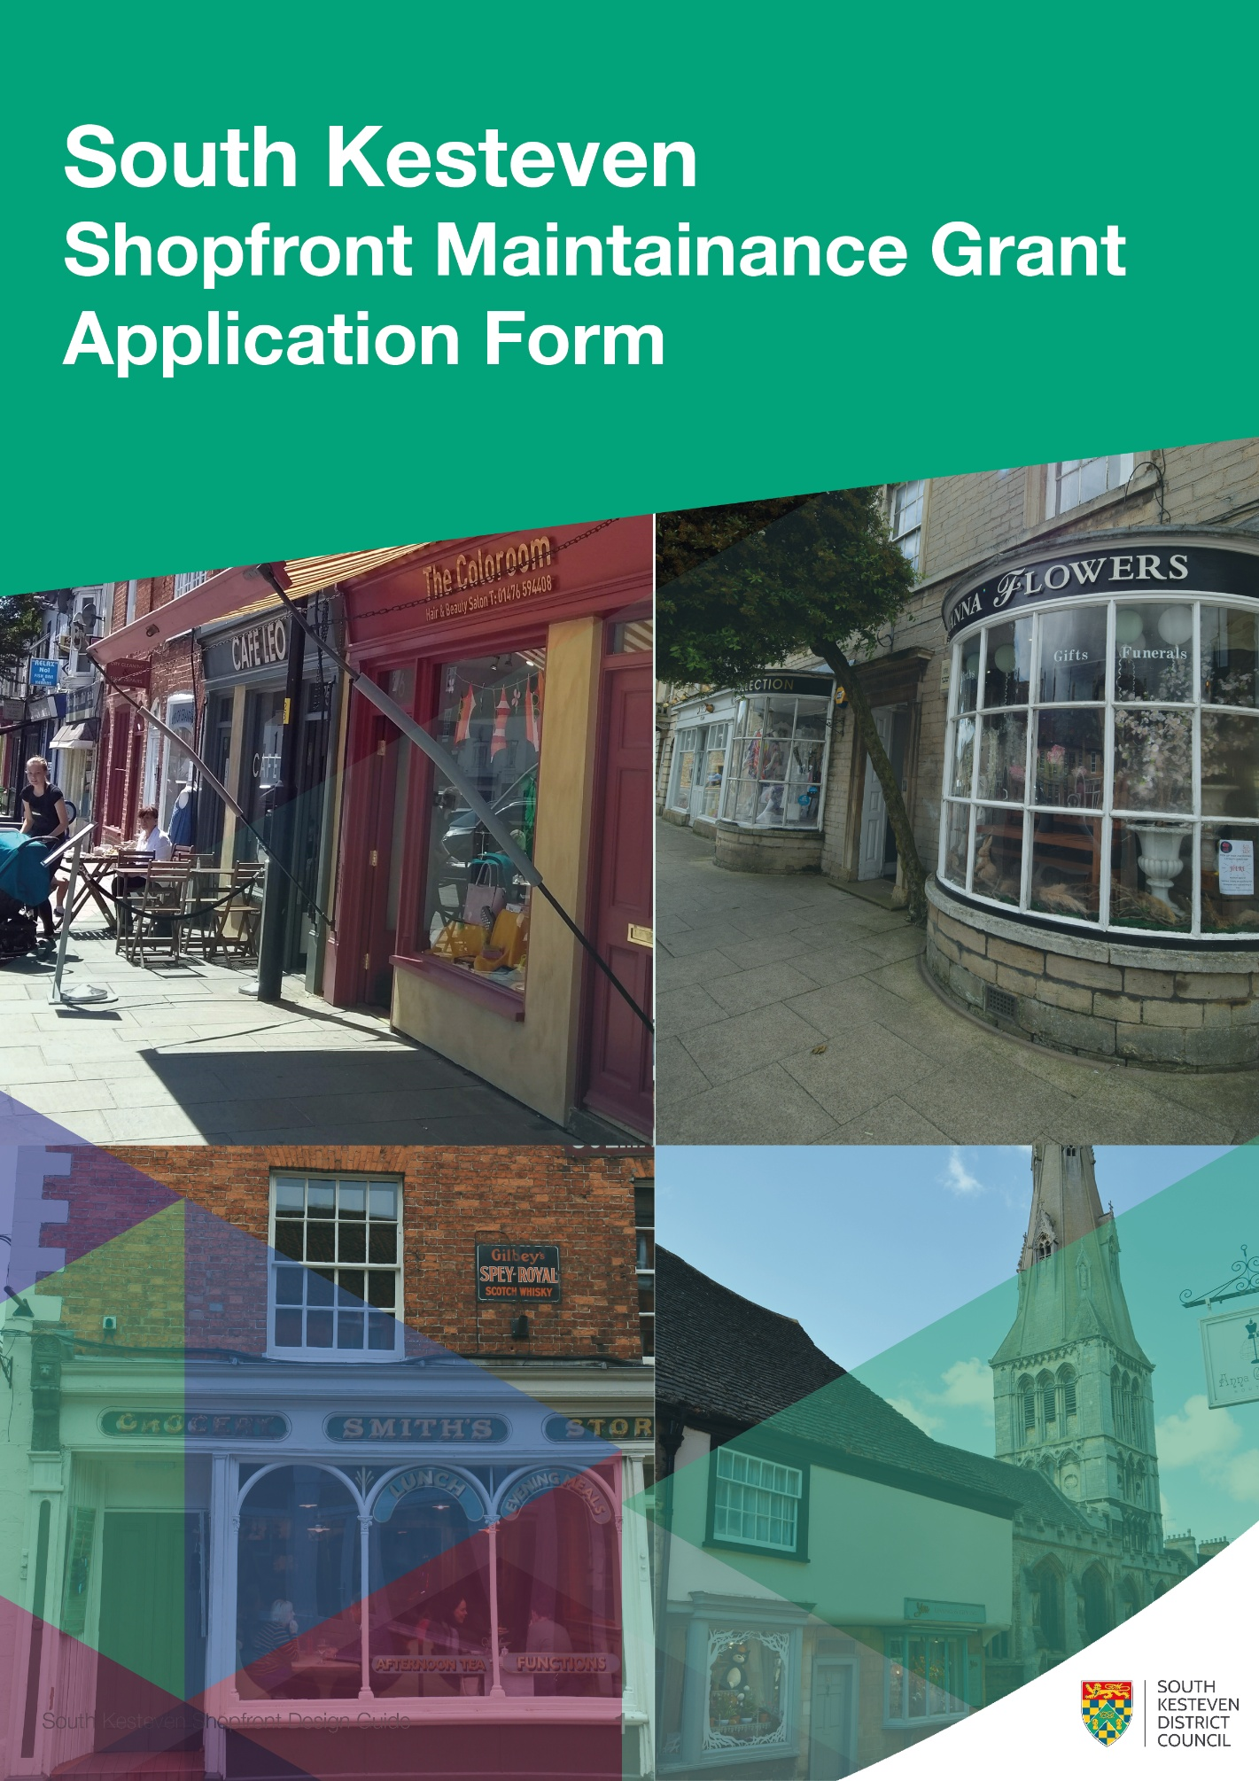

Please read ‘South Kesteven Shopfront Maintenance Grant Guidance’ before completing this application form.

Applicant Details
Applicants should be the tenant or owner/occupier of the property where the grant work will be carried out.
Please provide the name and contact details of the applicant:
Name:
Address:
Contact Email:
Contact phone:

Agent/ Representative
If you are acting as an agent or representative of the tenant and are completing this application on behalf of the property tenant, please provide your name and contact details:
Name:
Address:
Contact Email:
Contact phone:

Property Details
Please provide details of the property for which the grant is sought
Business Name:
Address:
Length of time business has occupied the property:
Length of remaining lease/ operator’s license:

Is the property listed: Grade I Grade II* Grade II Not Listed

Project Details
Please provide as much detail as possible about the work you wish to carry out.
- If you are planning on repainting a shopfront, you should include details of the planned paint color
- If you intend to change signage, you should include the design of the new sign, or if not available, examples of similar signage
- If you are carrying out repairs, please provide the specification of repairs (where known)
- Please provide a current photograph of your shopfront

Project Costs
Please use the table to tell us the total cost of your project (if known), and the total value of grant you are requesting.
If you can reclaim VAT through your business, VAT costs should not be included.
We are not able to fund any capital work undertaken prior to a signed grant agreement being in place.
If you are successful in your grant application, we are able to fund professional or planning fees which are directly related to the completion of the project which may have been incurred before a grant agreement is in place, please include these in the costs.
Please note we are not able to fund planning of professional fees occurred for applicants who are not successful in their bid.
Total Project Cost | £
Total Grant request | £

If your project cost is greater than the grant request, please tell us how you are funding the remaining costs (e.g. self-funded, other grant, loan funding etc.), and if this funding is confirmed:

Breakdown of costs:
Please use this table to provide as much detail as possible about the costs of the project.
Please state if your figures are based on quotes. If you do not yet have a quote for the works, please let us know how you have estimated the cost.
Please provide as much detail as you can, add rows if necessary.
Item | Cost (£) | Rationale for cost
EXAMPLE: Repainting shopfront | 2000.00 | Quotation

Please Note: South Kesteven District Council are not under obligation to increase the value of grant funding offered should project costs be higher than outlined in this application. The applicant will be responsible for any costs above the grant offer.
Successful applicants will need to demonstrate that they have complied with the procurement requirements of the scheme, and obtained the required number of quotations, before funding is released.

Status of Permissions
Applicants are not required to have all necessary permissions in place before applying but must provide us with evidence of them before the grant will be paid.
If a successful applicant fails to secure the necessary permission to complete the works the grant will be withdrawn and costs relating to the failed application will not be reimbursed.
Please select as appropriate:
Permission from landlord: Granted/ Pending/ Not required
If not required please explain why:
Planning permission: Granted/ Pending/ Application not yet submitted/ Not Required
Listed Building Consent: Granted/ Pending/ Application not yet submitted/ Not Required
Advertising Consent: Granted/ Pending/ Application not yet submitted/ Not Required

Supporting Documents
Please provide the following supporting documents:
A recent photograph of the shopfront
Where available please provide:
Relevant designs/ drawings
Relevant specifications
Relevant quotations

Please return your completed application and supporting information by email to
claire.saunders@southkesteven.gov.uk
The deadline for applications is 15th September 2026 (midnight).

